**SYNOPSIS**

***ON***

***CARCRUISE***

TO BE DEVELOPED TO FULFILL THE REQUIREMENT FOR

THE INTEGRATED PROJECT (22CA)

SUBMITTED TO

Department of Computer Applications

Chitkara University, Punjab



UNDER THE SUPERVISION OF

Dr.Amandeep Bhullar Dr.Jaspreet Bajaj

Associate Professor Associate Professor

SUBMITTED BY

RIYA 2210997197

BACHELORS OF COMPUTER APPLICATIONS

(Batch 2022-2025)

Table of Content :

1. Abstract
2. Introduction

2.1) Project Aim and Objective .

2.2) Technology to be Used .

2.3) Hardware and Software Requirements .

3) System Analysis.

3.1) Software Requirement Specification.

3.2) Existing v/s proposed system.

4) Flowchart

5) Timeline

6) References.

1. **Abstract :**

Welcome to the future of hassle-free and convenient car rentals! Our cutting-edge Car Rental website redefines the way car owners share their vehicles and how customers experience the freedom of driving without the commitment of ownership. Here the road meets innovation, and car ownership transforms into a shared and convenient experience. Our platform is designed to connect car owners with those in need of reliable transportation, creating a community-driven solution for hassle-free car rentals. The envisioned website serves as a comprehensive platform for vehicle owners to rent out their cars and for users to easily find, rent, and enjoy the experience of driving a variety of vehicles.The Car Rental System is being developed for customers so that they can book their vehicles from any part of the world. This application takes information from the customers through filling their details. A customer being registered in the website has the facility to book a vehicle which he requires. It is an online system through which customers can view available cars, register and book car. We developed this project to book a car on rent at the fare charges. In present system all booking work done manually and it takes very hard work to maintain the information of booking and cars. if you want to find which vehicle is available for booking then it takes a lot of time. It only makes the process more difficult and hard. This aim of the project is to automate the work performed in the car rental management system like records of cab, cabs available for booking, rental charges for cars, store records of the customer. Cars is a car booking software that provides a complete solution to all your day-to-day car booking office running needs. This system helps you to keep the information of customer online. You can check your customer information any time by using this system. Online car rental management system is a unique and innovative product. Based on this information you can take decision regarding your business development.

1. **INTRODUCTION :**

Welcome to the Car Rental System, an innovative solution designed to enhance the way customers book vehicles from any corner of the globe. In a world where convenience is paramount, this online application simplifies the process of renting cars by allowing users to seamlessly provide and access information.

Traditionally, managing car bookings and maintaining customer details has been a manual and labor-intensive task. The current system requires significant effort to keep track of available cars, customer records, and booking information. Locating an available vehicle involves considerable time and effort, making the entire process cumbersome.

In response to these challenges, our project aims to revolutionize car rental management by introducing an automated, user-friendly system. This platform empowers customers to view, register, and book cars at competitive rates, eliminating the hassles associated with traditional booking methods.

The Car Rental System streamlines operations, offering a comprehensive solution for managing cab records, checking vehicle availability, determining rental charges, and maintaining customer information. This innovative software, known as Cars, takes car booking offices to new heights, providing a centralized hub for all essential functions.

With the online car rental management system, customers and businesses alike benefit from the convenience of accessing and managing information anytime, anywhere. The system's unique features enable efficient decision-making for business development based on real-time data.

**Objectives :**

* To produce a web-based system that allow customer to register and reserve car online and for the company to effectively manage their car rental business.
* To ease customer’s task whenever they need to rent a car.
* As all the system is computerized, there is no need to fill any application form for renting purpose. So, the paperwork will be very less.
* To make sure a user gets his desire car as early as possible. The car rental system will provide a faster response to complete the process.

**2.1) Project Aim and Objectives:**

**Aim:** The Car Rental System (Cars) project is developed with the primary aim of modernizing and streamlining the car rental process for customers on a global scale. By leveraging online technology, the project seeks to eliminate manual efforts and complexities associated with traditional car booking systems.

**Objectives:**

1. **Global Accessibility:**
   * Enable customers to effortlessly book vehicles from any part of the world, breaking down geographical barriers.
2. **Efficient Data Collection:**
   * Develop an application that collects customer information through a user-friendly interface, simplifying the booking process.
3. **User Registration and Booking Facility:**
   * Provide customers with the ability to register on the website, empowering them to book vehicles that meet their specific requirements.
4. **Online System:**
   * Establish an online platform where customers can seamlessly view available cars, register, and complete the booking process, enhancing convenience.
5. **Fair Rental Charges:**
   * Set up a transparent system for determining fair rental charges, ensuring customers receive competitive pricing for their vehicle rentals.
6. **Automation of Manual Processes:**
   * Eliminate the manual efforts associated with the traditional car rental system, reducing workload and increasing efficiency.

**2.2) Technology to be Used:**

**HTML5 :**

HTML5 is a markup language used for structuring and presenting content on the World Wide Web. It is the fifth and last major HTML version that is a World Wide Web Consortium (W3C) recommendation. The current specification is known as the HTML Living Standard. It is maintained by the Web Hypertext Application Technology Working Group (WHATWG), a consortium of the major browser vendors (Apple, Google, Mozilla, and Microsoft)[1].

**CSS3 :**

Cascading Style Sheets (CSS) is a style sheet language used for describing the presentation of a document written in a markup language such as HTML. CSS is a cornerstone technology of the World Wide Web, alongside HTML and JavaScript. CSS is designed to enable the separation of presentation and content, including layout, colors, and fonts. This separation can improve content accessibility; provide more flexibility and control in the specification of presentation characteristics; enable multiple web pages to share formatting by specifying the relevant CSS in a separate .css file, which reduces complexity and repetition in the structural content; and enable the .css file to be cached to improve the page load speed between the pages that share the file and its formatting.

**Javascript:**

JavaScript (JS) is a dynamic computer programming language. It is most commonly used as part of web browsers, whose implementations allow client side scripts to interact with the user, control the browser, communicate asynchronously, and alter the document content that is displayed. It is also being used in server-side programming, game development and the creation of desktop and mobile applications. JavaScript is a prototype-based scripting language with dynamic typing and has first-class functions. Its syntax was influenced by C. The key design principles within JavaScript are taken from the Self and Scheme programming languages. It is a multiparadigm language, supporting object-oriented, imperative, and functional programming styles.

**Php:**

PHP is a server-side scripting language designed for web development but also used as a general-purpose programming language. PHP is now installed on more than 244 million websites and 2.1 million web servers. Originally created by Rasmus Lerdorf in 1995, the reference implementation of PHP is now produced by The PHP Group. While PHP originally stood for Personal Home Page, it now stands for PHP: Hyper Text Preprocess .PHP code is interpreted by a webserver with a PHP processor module, which generates the resulting web page PHP commands can be embedded directly into an HTML source document rather than calling an external file to process data. It has also evolved to include a command-line interface capability and can be used in standalone graphical applications. PHP is free software released under the PHP License. PHP can be deployed on most web servers and also as a standalone shell on almost every operating system and platform, free of charge.[3]

**SQL:**

SQL (Structured Query Language) is a standardized programming language that's used to manage relational databases and perform various operations on the data in them. The uses of SQL include modifying database table and index structures; adding, updating and deleting rows of data; and retrieving subsets of information from within a database for transaction processing and analytics applications. Queries and other SQL operations take the form of commands written as statements -- commonly used SQL statements include select, add, insert, update, delete, create, alter and truncate. MySQL is a popular choice of database for use in web applications, and is a central component of the widely used LAMP open source web application software stack (and other 'AMP' stacks).[2]

**APACHE WEB SERVER :**

In this project apache server is used to parse and execute PHP pages, before deploying websites on the server, the website should be tested at the developer side to get a feel of how the website will work on actual server. Therefore apache server is like a local server on the developer side, apache server should be informed about the environment on which it should work. In our project apache server is configured to work with PHP, in this way all the PHP pages are parsed and executed by the server. When apache is installed on the system, then it services is controlled by apache service monitor.

**2.3) Hardware and Software Requirement :**

**Hardware Requirements :**

* Processor : Intel i3/i5/1.8GHz machine or above.
* Primary memory : 4 GB RAM or above.
* Hard disk drive : 1 TB or greater.

**Software Requirements:**

* Operating system : Windows 7 or higher.
* Front End : HTML5,CSS3,JavaScript.
* Back End : PHP, SQL.
* Frame work : Bootstrap.
* Software : Visual Studio Code, XAMPP.

1. **System Analysis:** Software Requirement Specification to be discussed here .

**3.1)REQUIREMENT ANALYSIS AND SPECIFICATION :**

**Functional Requirements Car Rental System:**

These are statements of services the system should provide, how the system should react to particular inputs and how the system should behave in particular situations. In some cases, the functional requirements may also explicitly state what the system should not do. The functional requirements for a system describe what the system should do. These requirements depend on the type of software being developed, the expected users of the software and the general approach taken by the organization when writing requirements. When expressed as user requirements, the requirements are usually described abstractly. However, functional system requirements describe the system function in detail, its inputs and outputs, exceptions, and so on. Functional requirements for a software system may be expressed in several ways.

**The functional requirements of CAR RENTAL SYSTEM is as follow:**

**Register Module:**

* The user needs to provide their first name, last name, email, license number, phone number, password, confirm password, gender for registration.
* These details will be stored in database.

**Login Module:**

* For login user will input their email and password .
* Admin will provide their admin id and password which will compared with a database content.

**Booking Module:**

* User can view the list of cars. The booking details of cars are provided by the admin.
* User can select their preferred car and book for the same.

**Payment Module:**

* User should able to make payment by filling card number, expiry date and CVV are provided by the admin.
* After payment user will get the payment successful popup window.

**Logout Module:**

* The system should allow user to logout .
* The system should also allow admin to logout.

**Software Requirements:**

* Operating system : Windows 7 or higher.
* Front End : HTML5,CSS3,JavaScript.
* Back End : PHP, SQL.
* Frame work : Bootstrap.
* Software : Visual Studio Code, XAMPP.

**Non-Functional Requirements of Car Rental :**

System Non-functional requirements are requirements that are not directly concerned with the specific functions delivered by the system. They may relate to emergent system properties such as reliability, response time and store occupancy. Alternatively, they may define constraints on the system such as the capabilities of I/O devices and the data representations used in system interfaces. The plan for implementing functional requirements is detailed in the system design. The plan for implementing non-functional requirements is detailed in the system architecture. Non-functional requirements are often called qualities of a system. Other terms for non-functional requirements are "constraints", "quality attributes", "quality goals", "quality of service requirements" and "non-behavioral requirements". Qualities, that are non-functional requirements, can be divided into two main categories: Execution qualities, such as security and usability, which are observable at run time.

**Security:**

* The system should provide a high level of security and integrity of the data held by the system , only authorized personnel of the comspany can gain access to the company’s secured page on the system.
* System provides security for the admin by allowing them to enter into the account with their respective ID and password.
* A user can only enter to their account by using their email and password. Only admin have privileges to update database contents which are used by the user.

**Performance:**

* The system should have high performance rate when executing user’s input and should be able to provide feedback or response within a short time span usually 50 seconds for highly complicated task and 20 to 25 seconds for less complicated task.
* The system provides user friendly interface, any common people with little knowledge can use the system.
* System is robust, reliable and fast, provides more efficiency.

**Reliability:**

* It is the probability and percentage of the system performing without any failure for a specific number of uses or amount of time.
* Car rental system provides reliable interface as it provides data security and data safety.
* User can rely on the details present in the system, since it is provided by the admin.

**Consistency:**

* The car rental system provides consistency services, by retaining the data present in the database.
* The user gets the details that are only provided by the admin, thus achieving correctness of data in the database.

**3.2) Existing V/S Proposed Software :**

**Customer Registration:**

* Existing System: Manual registration of customers involves paperwork and manual entry of customer details.
* Proposed System: Implement an online registration system for customers to enter their details, making the process more efficient and user-friendly.

**Vechile Booking :**

* Existing System: Manual booking process where customers need to physically visit or contact the rental office.
* Proposed System: Introduce an online booking system that allows customers to view available cars, choose their preferences, and book a vehicle from anywhere in the world.

**Information Retrieval:**

* Existing System: Time-consuming manual search to find available vehicles and customer information.
* Proposed System: Implement a search functionality to quickly retrieve information about available cars, customer records, and booking details.

**Global Accessibility :**

* Existing System: Limited accessibility as customers need to visit the physical office.
* Proposed System: Make the system accessible globally by allowing customers to book cars online from any part of the world.

1. **FLOWCHART :** A flowchart is a diagram that depicts a process, system or computer algorithm. They are widely used in multiple fields to document, study, plan, improve and communicate often complex processes in clear, easy-to-understand diagrams. Flowcharts, sometimes spelled as flow charts, use rectangles, ovals, diamonds and potentially numerous other shapes to define the type of step, along with connecting arrows to define flow and sequence. They can range from simple, hand drawn charts to comprehensive computer-drawn diagrams depicting multiple steps and routes.

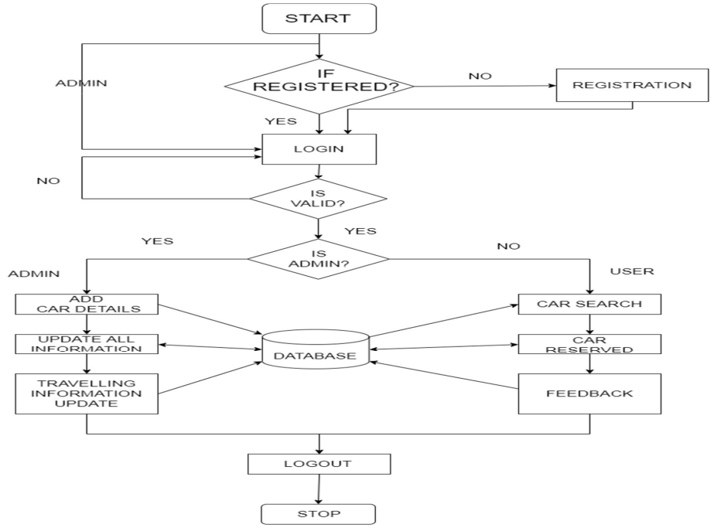

In the Figure , the user/admin enters his credentials for registration and later logins. If the login credentials are correct and authentic, he is redirected to his web page. If an admin is an authorized user, he is given the privilege of adding, updating the car, booking, payment details. If an authentic user logs in, he gets the details of car and other related details, then he can view list of cars then he can book car by providing valid details then he can get the booking status of booked status of after making payment. After performing all the operations, the user and admin can save and log out.

1. **Timeline:**

|  |  |  |  |  |
| --- | --- | --- | --- | --- |
|  | 8 january-30 january ,2024 | 01 febuary -29 febuary ,2024 | 01 march-31 march,2024 | 01 april-07 april,2024 |
| Synopsis Submission |  |  |  |  |
| Designing(Architectural  and database design) |  |  |  |  |
| Implementation |  |  |  |  |
| Report Writing |  |  |  |  |
| Final Submission |  |  |  |  |

1. **References :**
   1. <https://www.geeksforgeeks.org/html-tutorial/>
   2. <https://www.w3schools.com/sql/default.asp>
   3. https://www.w3schools.com/php/default.asp